Invoice Processing can be challenging, but with UiPath, you get all the tools you need to build customized, scalable, and complete solutions to this challenge and millions more. Thanks to UiPath 20.4 and all the new features that come along with it, in less than 15 minutes you can trial how invoice processing works with proprietary machine learning technology to read and process millions of different invoices in under 15 minutes. Follow this guide to try it out for yourself. This is massive for our SMB space customers that solutions that can work quickly!

**Step 1 Create a cloud account in the Automation Cloud**

1. Access <https://Platform.uipath.com>
2. Access your orchestrator instance to test.

**Step 2 Install a Robot on your local machine**

Request an Enterprise Trial and go the resource center and download UiPath 20.4 latest release

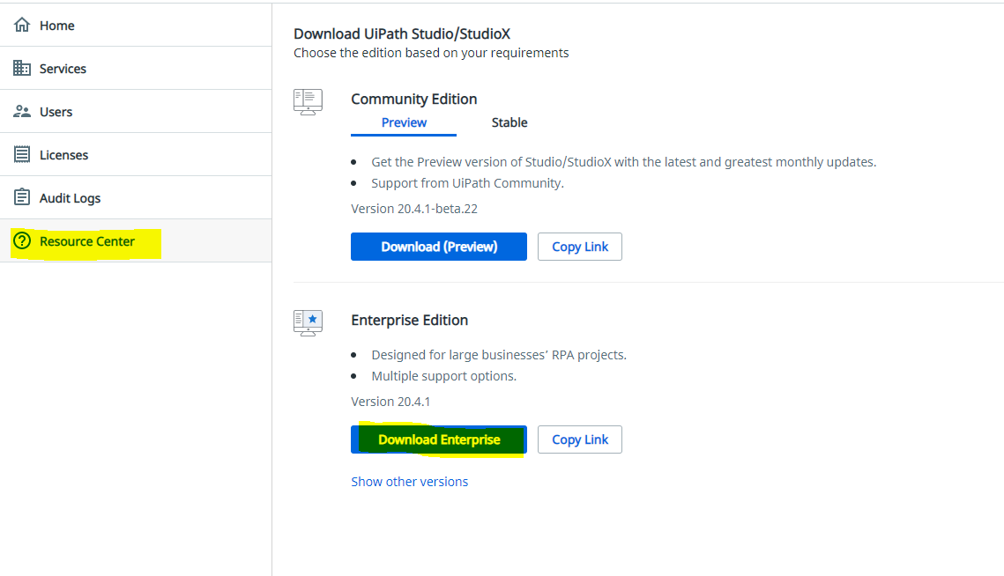

**Step 3 Connect Robot to orchestrator**

1. You can follow this guide - <https://docs.uipath.com/orchestrator/docs/connecting-robots-to-orchestrator>
2. Create new Robot environment so you can run a process.

**Step 4 Pull down this project. Download the zip file and unzip it.**

<https://github.com/shazeltion17/InvoiceProcessingMain>

NOTE: Make sure you open the project from the project.json file so all the libraries come along with it.

**Step 5 Plug in your API Key**

1. Open “InvoiceProcessor.xaml” file, locate Machine learning Extractor and enter your API Key.

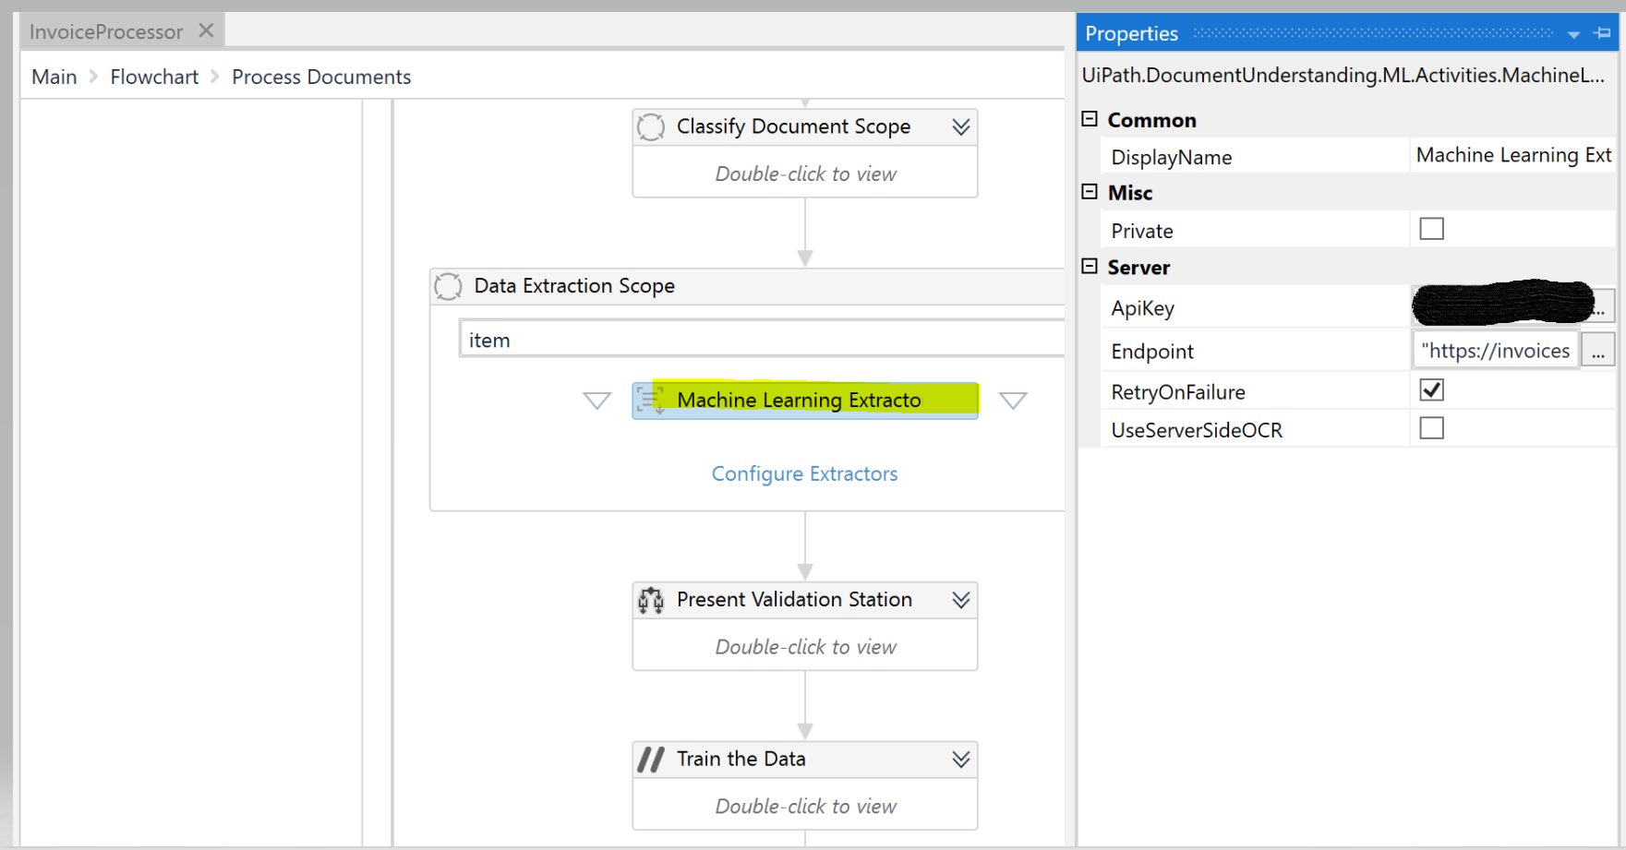

1. You can get your API from the License page in your cloud portal

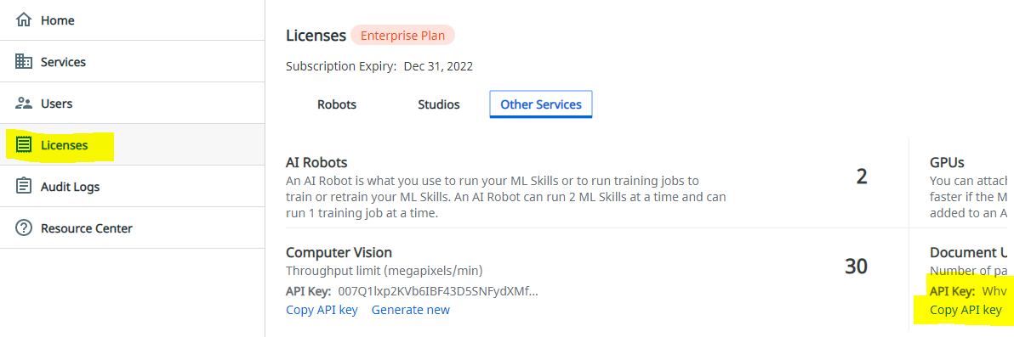

**Step 6 Run your process**

1. Add your sample invoice to this folder: IOCR2.0\testDocs\PDFs
2. Run the “Validation Station Extraction.xaml” file
3. When the form pops up, click on invoices